Year 9 RE: Healing and Hope

The Sacraments of Penance and Reconciliation

The next topic in year 9 Religious Education is *Healing and Hope*. In this unit we will focus on the sacrament of Penance/Reconciliation.

There is ONE chapter in your text book relevant to this topic;

* **Chapter 9: Penance and Reconciliation**

In addition to your text book, this unit will also make use of the resource called Healing and Hope Resource Booklet. You can find this in SIMON and on MSTeams Files.

This booklet will guide you through which exercises and activities to complete in order to gain a full understanding of the sacrament. Some of the readings and activities will be from your text book and some will be from this booklet. This booklet will be graded as your Workbook for this unit of study.

**Student name:**

**Student Tutor Group:**

**Teacher’s name:**

**Sacrament of Reconciliation**

**Chapter 9: To Know Worship and Love**

**Pre Task 9.1** Read togeher

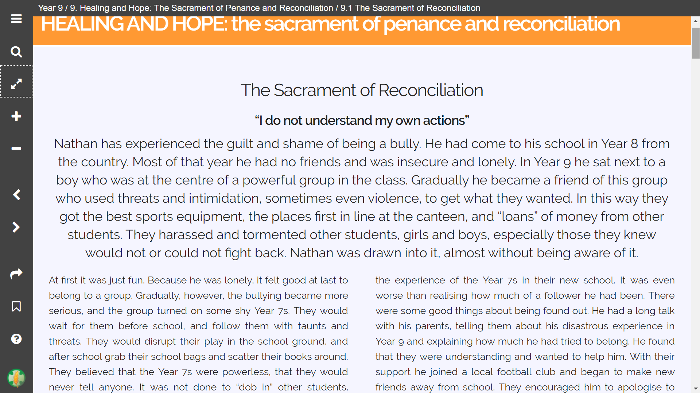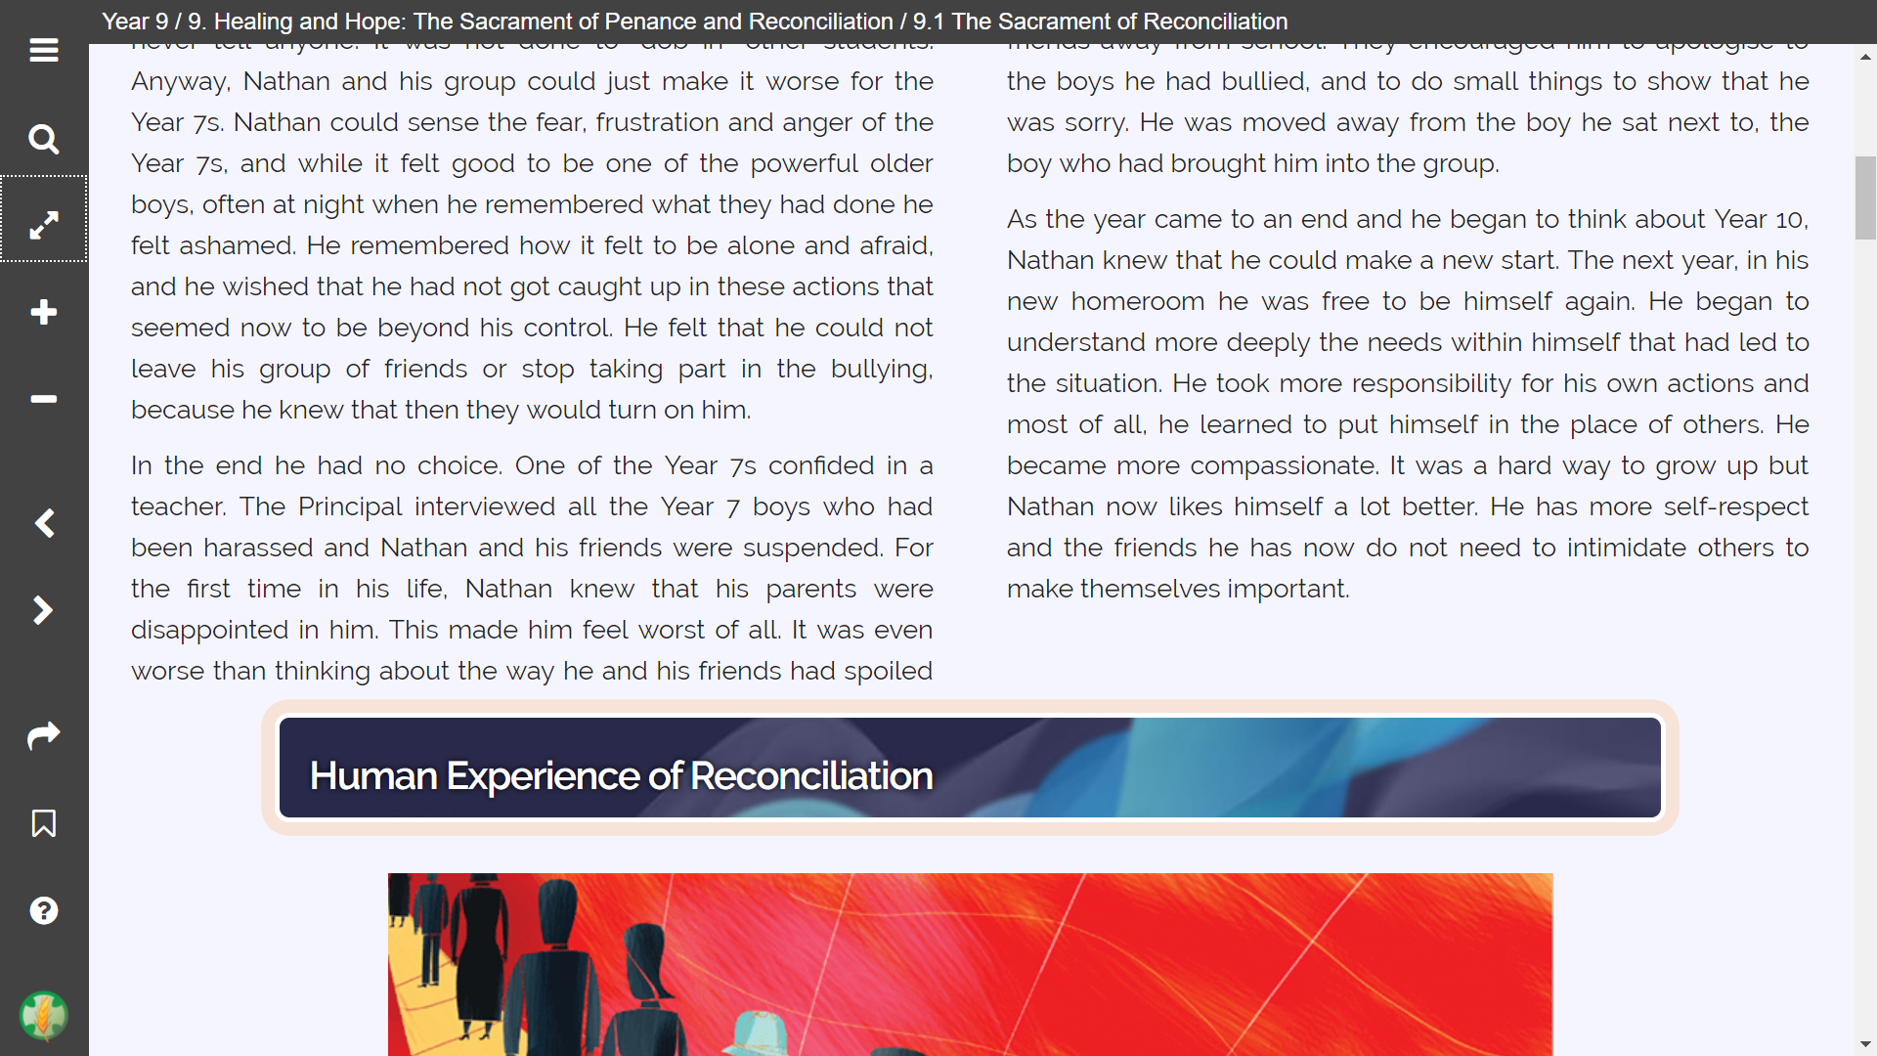

**Question 1:** What are three words that you would use to describe the experience that Nathan had in the story above:

Difficult, Wrong, but Escapable

**Question 2:** What are some of the pressures that Nathan felt?

He thought that leaving the group would cause him to get bullied. Peer pressure and bullying.

**Question 3:** What aspect of ‘healing’ did we see in the story?

Now that Nathan was in a different homeroom, he can get a fresh start and change his personality. He also started distancing himself from his friend group.

Read from TKWL: **Healers in Our Communities and Jesus and Healing**

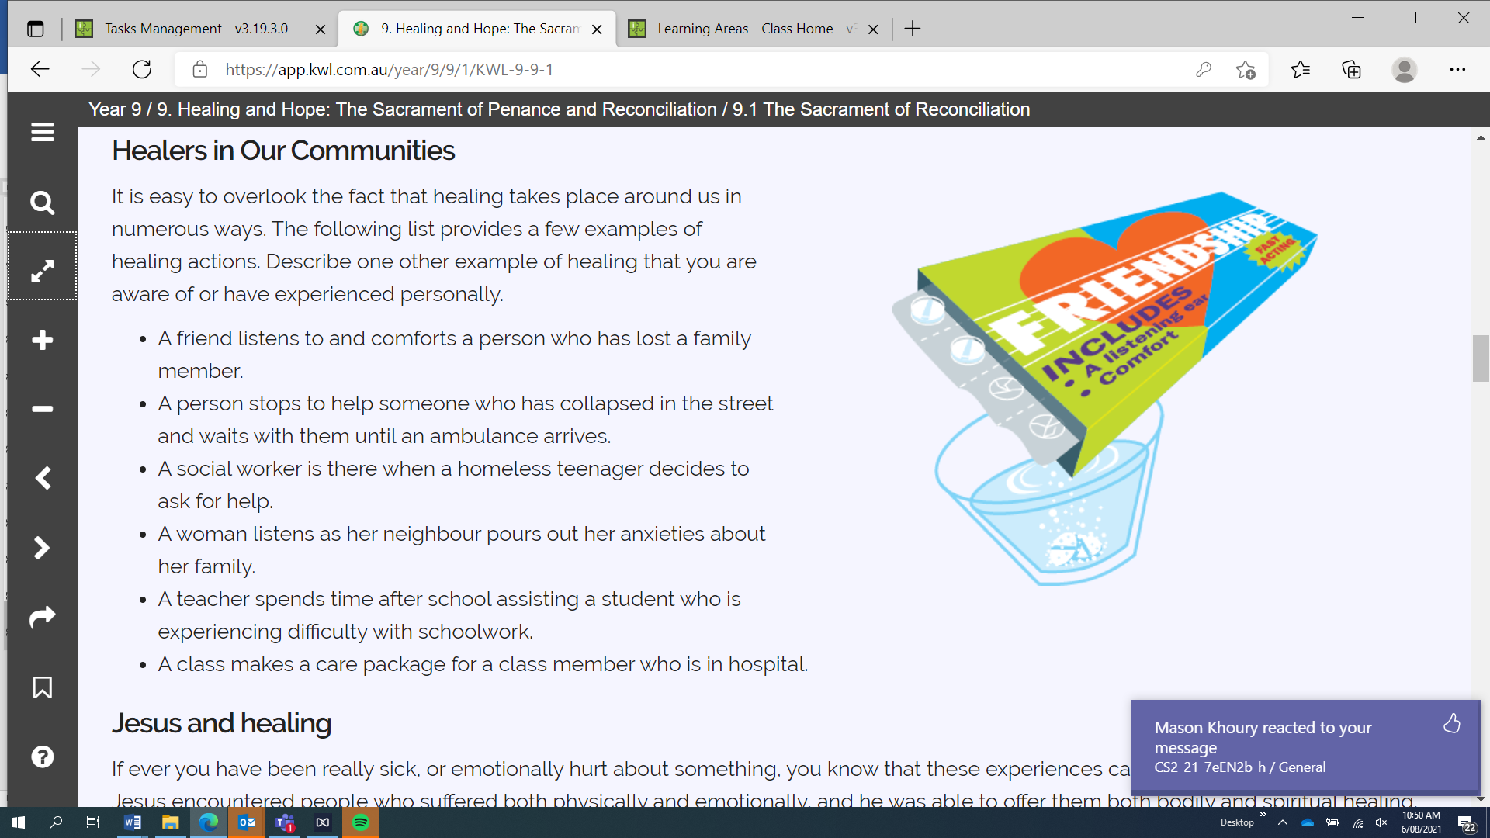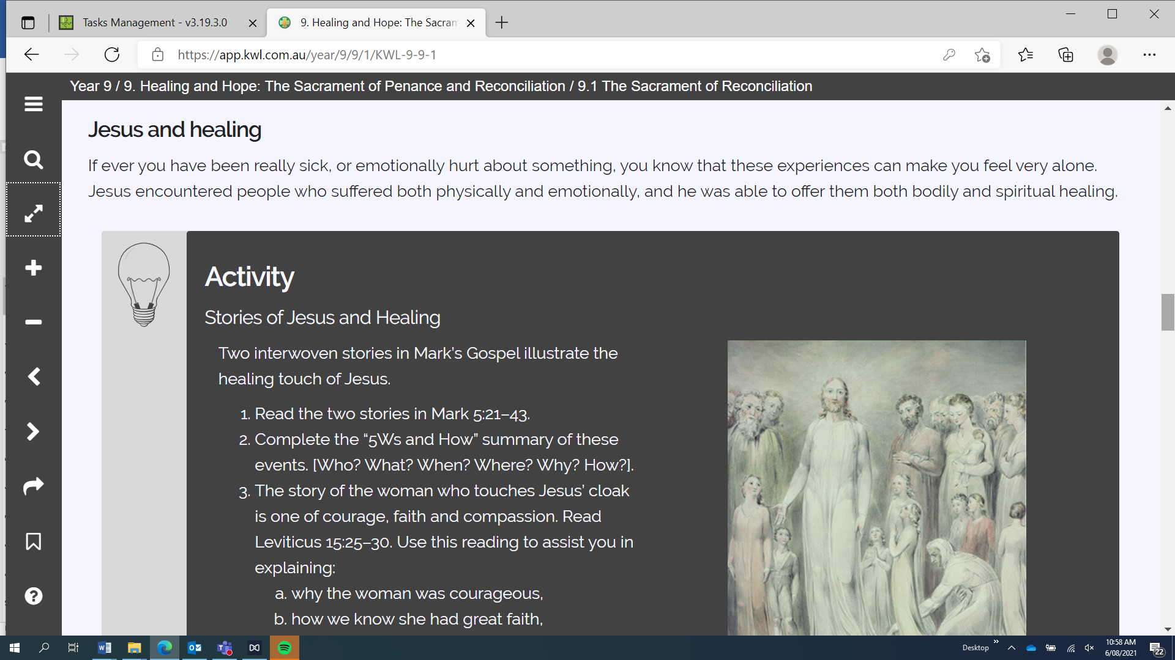

The healing of Jesus also demonstrated his true power; that he was the Messiah. Death is not a serious barrier

* 1. *Pick* ***one*** *of the Healing stories from TKWL. Use biblegateway.com to look up one of the stories.*

|  |  |
| --- | --- |
| Luke 6:6–11 |  |
| Luke 13:10–17 |  |
| Matthew 9:1–8 |  |
| John 9:1–12 |  |
| Luke 18:35–43 |  |

*Read it and fill out your response below.*

*What happens in the story?*

*Pharisees and teachers watch Jesus to see if he would heal on the Sabbath day. Jesus gets a man with a badly injured hand to stand. Jesus asks the people about the Sabbath day, and then heals the man’s hand.*

*What kinds of healing does Jesus offer the sick person?*

*Jesus heals the man’s hand, making it better, which is physical healing.*

*Ideas about Jesus are there in the story?*

*Jesus is capable and willing to help out those in need. Jesus is also capable of reputing those who are against him.*

* 1. *For the gospel story written about above,* ***re-write it in the form of a brief letter in the perspective of the person who was healed.***

*To Jesus,*

*I’m not certain of what you did to me while you were teaching last Saturday, but I thank you dearly and greatly. You have healed my injuries and have transformed my hand back to what it once was. I can’t thank you enough.*

*Thanks Again,*

*Follower.*

**Task 1:**

Read: **Defining Sin**

**Defining Sin**

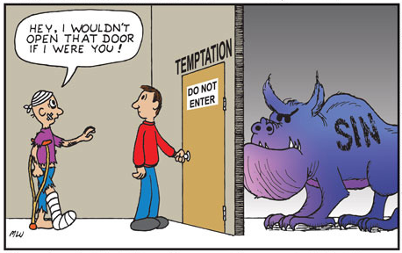

|  |  |
| --- | --- |
|  |  |

1. What types of Sin do you see in the pictures?

Lying

Plagiarism

Temptation

**Understanding Sin**

Read **The Need for Spiritual Healing** from TKWL

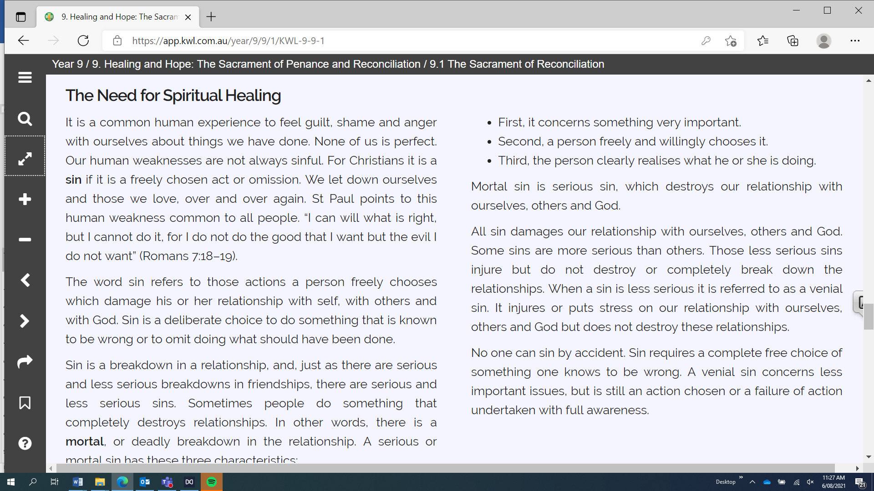

Watch: [Mortal Sin vs. Venial Sin - YouTube](https://www.youtube.com/watch?v=IhCz_q9Sh1c)

Answer the following questions:

1. What does the word sin refer to?

An offense against God, which damages our relationship with God. Sin separates your relationship with God.

1. What is **mortal** sin?

A grave sin that destroys your relationship with God, separating you from Him.

1. List the **three characteristics** of mortal sin.

It must be of a grave matter; it is a serious act (aka breaking one of the commandments.

It must be committed with full knowledge that it is a mortal sin; you know what you are doing is wrong.

It must be committed with full consent. You freely choose to do it.

1. When we sin, what **three** persons with whom we have a relationship with are affected?

God, the person you have sinned against, and yourself.

Read **‘Venial Sin’**

**Venial Sin**

|  |  |
| --- | --- |
|  |  |

Venial sin is less serious and the most common of sins. While it does not break our relationship with God and neighbour, venial sin corrodes these relationships and weighs us down with bad habits.

*Venial sin allows charity to subsist, even though it offends and wounds it.*

**- Catechism of the Catholic Church, #1855**

Venial sin is expressed in,

* the lack of care we show for others
* our own self-interest
* Demeaning words, gossip and the like.

A **venial** **sin** consists in acting as one should not, without the actual incompatibility with the state of grace that a mortal sin implies; they do not break one's friendship with God, but injure it.

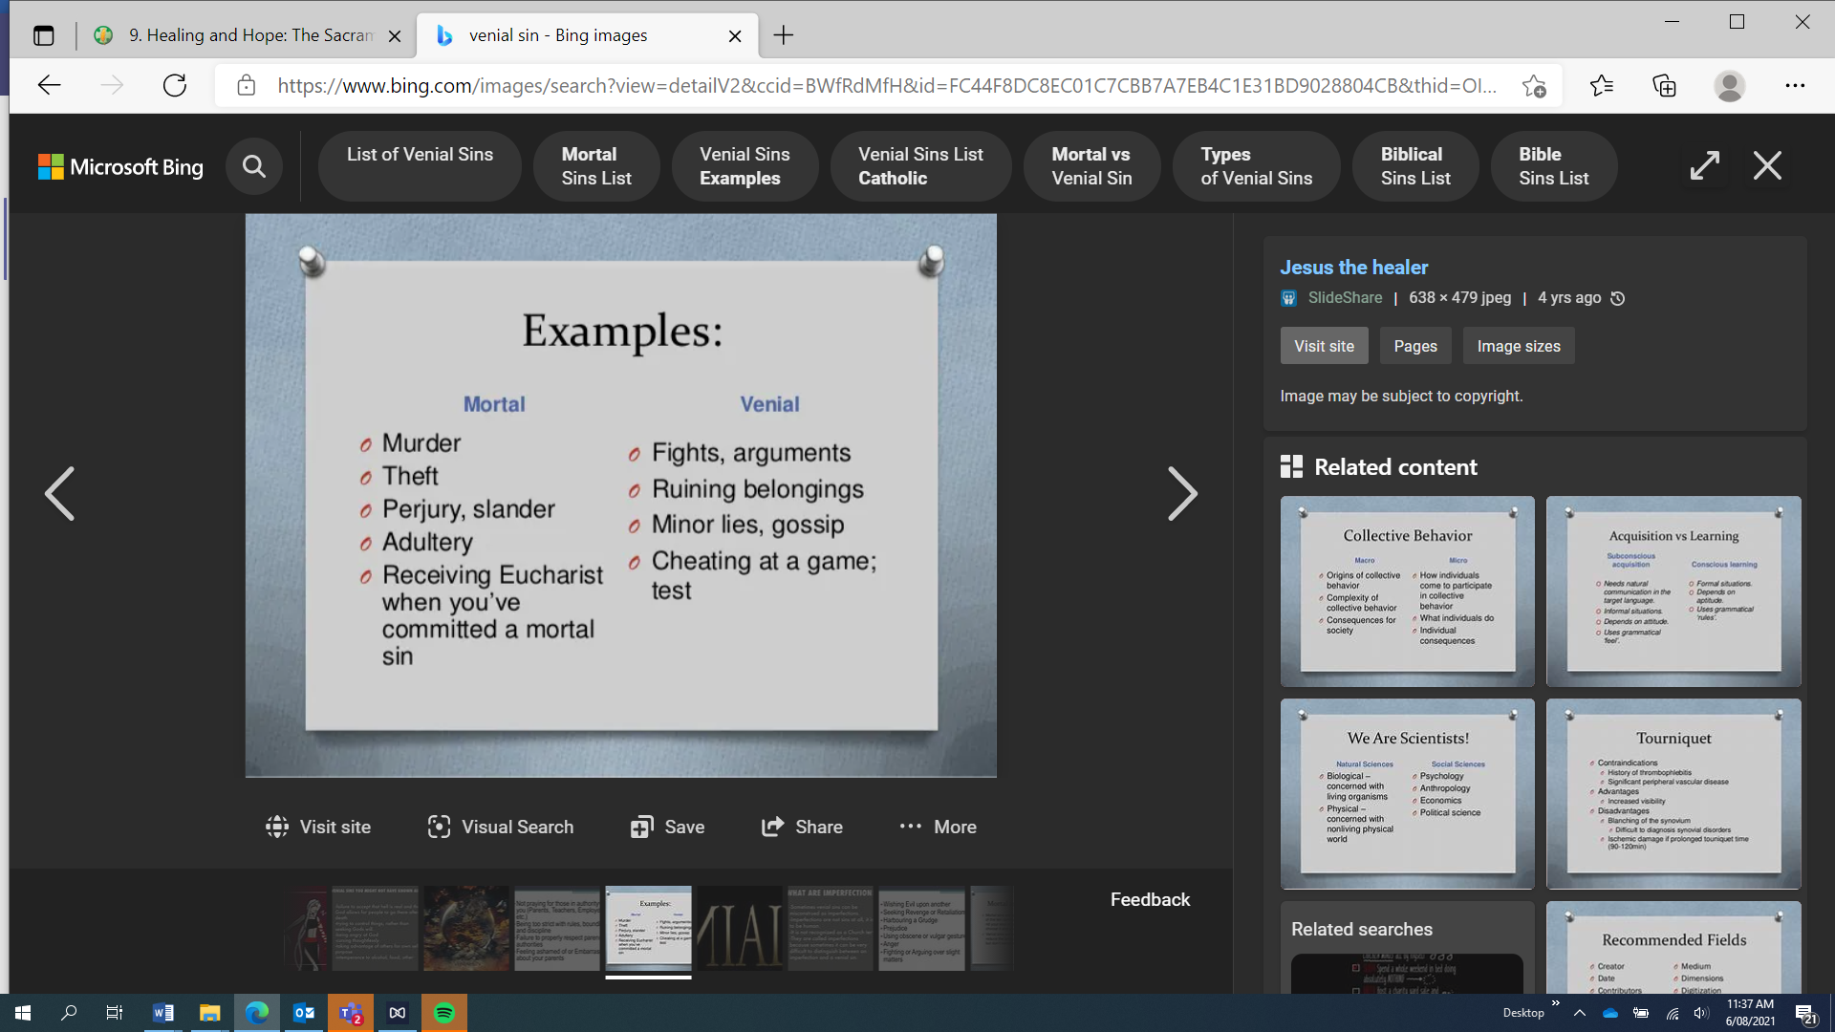

* 1. *Give three examples of ways someone you know has committed a venial sin or if you have:*

*1. Fighting a kid. 2. Talking behind someone’s back. 3. Cheating in a game*

***Seven Capital Sins***

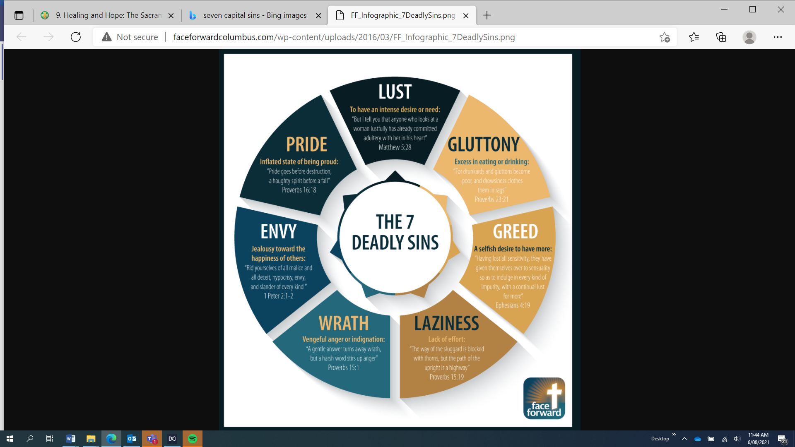

These Capital Sins can be classified as habits which are developed over time, this makes it easier to do evil than to do good. For each Capital Sin there is a positive opposite. E.g. Greed/Generosity

Activity: For each of the 7 Capital Sins include what you think the Virtue (positive) would be:

Lust – When a person seeks sex for pleasure.

Pride – The excessive belief in one’s own ability and the excessiveness of being proud of yourself and bragging.

Envy – Being extremely jealous of someone’s characteristics or possessions.

Wrath- Extreme anger.

Laziness – Being lazy and unmotivated to do something such as work. Lack of effort.

Greed- Being selfish and wanting everything for oneself

Gluttony- Excess in eating or drinking

Read **Social Dimension of Sin** from the resource booklet.

**Social Dimension of Sin**

**Definition**

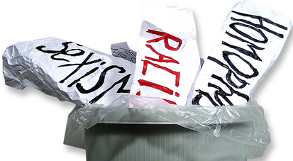

When we hear the term 'social sin', we tend to think of social evils such as sexism, racism, genocide and the oppression of the poor. However, every personal sin has a social dimension, i.e. whatever we do has an effect on others.

For example, if I am grumpy and I shout and slam the door as I run into my bedroom, my behaviour can affect those around me. They can become angry, impatient, distressed, or even deprived because of my behaviour. More obvious are the sins that directly hurt my neighbour, such as put downs or name calling.

*With greater or lesser violence, with greater or lesser harm, every sin has repercussions on the entire (Body of Christ) and the whole human family ... every sin can undoubtedly be considered as social sin.*

**- 'Reconciliation and Penance', #16**

[**www.vatican.va**](http://www.vatican.va/holy_father/john_paul_ii/apost_exhortations/documents/hf_jp-ii_exh_02121984_reconciliatio-et-paenitentia_en.html)

Five attitudes or beliefs that can lead to social sin include,

1. **ageism** - belief that some people deserve better treatment and have more rights because of their age
2. **materialism** - belief that happiness comes from having lots of possessions and a high standard of living
3. **sexism** - belief that some people are better and more deserving of rights because of their gender
4. **racism** - belief that some people deserve better treatment and have more rights because of the colour of their skin
5. **homophobia** - belief that homosexual people are to be feared and are less deserving of rights because of their sexual orientation.  ***Understanding Faith*, 'Sinfulness and Reconciliation',  
   2011 Multimedia Edition, Emmaus Foundation, Port Macquarie, Part 1, p.6**

***Activity: For each of the Social Sin’s write an example (draw on your own experiences and any news events you have heard of).***

|  |  |
| --- | --- |
| *Ageism* | *An older person being fired because they aren’t as “reliable” as the younger workers.* |
| *Materialism* | *Buying goods when you are feeling sad, rather than addressing the issue you have.* |
| *Sexism* | *Women being paid less than men.* |
| *Racism* | *Yelling racial slurs at someone simply because they are a different race than you.* |
| *Homophobia* | *Making jokes about someone else being gay.* |

1. Read **Free Will**

#### Free Will

|  |  |
| --- | --- |
|  |  |

*The root of sin is in the heart of (the human being) in his (or her) free will, according to the teaching of the Lord: 'For out of the heart come evil thoughts ... '*

- Catechism of the Catholic Church, #1853

Another gift God gave to human beings is free will. It too, has been given solely to us and to no other creature, thereby contributing to the uniqueness of the human person. With free will, we can make choices and chart our own way through life.

Previously in this title it has been shown that the misuse of free will brought original sin into the world. When we choose to speak, act or desire anything that harms the health or well-being of any part of creation, we lessen who we are as human beings.

We make choices according to what we want, and this depends on our values, i.e. what is in our hearts. When our values support the good of ourselves, others and the environment, we can say they are according to the will of God. This is because God willed all goodness into being and keeps it there. If our values, the attitudes of our hearts, do not support the good of ourselves, others and the environment, they can lead to bad choices and decisions against the will of God. This is what is meant by the root of sin being in the heart of the human person.

*But in the heart also resides charity,  
the source of ... good and pure works ...*

- Catechism of the Catholic Church, #1853

* + 1. *What is Free Will? Give an example of when you have used your free will for the greater good. Give an example of when someone might use free will in the wrong way.*

*Free will is the power to do something without constraint or anything holding you back. One time I have used free will is when my parents need help doing the dishes. Even thought they haven’t told me to help them, I choose to help them. An instance of someone using free will in the wrong way is bullying someone because they like to see the receiver upset, and there’s no one there to stop them.*

1. Read **God is Merciful** from the resource booklet.

**God is Merciful**

The Prodigal Son and his Father

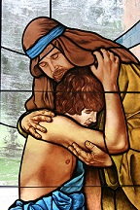

There is no need to let sin weigh us down with a distorted sense of guilt and self-blame. Sin is linked to salvation and where there is sin there is also grace. God loves us unconditionally. Jesus died and rose for us and offers salvation and reconnection with God, our neighbour and ourselves. When we acknowledge and express genuine sorrow for our sins, God forgives us.

*If we acknowledge our sins ... (God) is trustworthy and upright ... and will forgive our sins and ... cleanse us from all evil.*

Question: H*ow and why is God is merciful to us?*

*Because sin distorts our sense of guilt and self-blame, and can make us feel worse about ourselves. God doesn’t want us to feel this way because he understands the effects of sin, which is why he is merciful to us.*

**Forgiveness**

Read **Ceremonies of Forgiveness** and answer the questions that follow:

#### Samoan Ifoga

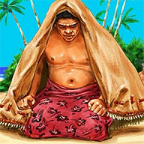

Samoan Ifoga Forgiveness

*In Samoa it is traditional for a wrong-doer to show sorrow and ask for forgiveness from the victim's family through the practice of ifoga, which takes place when a serious crime has been committed, e.g. murder. It involves members of the family of the wrongdoer going over to the family of the victim and sitting outside their village or house with fine mats covering their heads. There they wait and see if the victim's family will accept them. People are known to sit for hours, and in some cases days, awaiting forgiveness.  
If the Ifoga is accepted by the family of the victim, the wrong-doer's family present the fine mats that they had used to cover themselves, as well as other gifts to the victim's family. Today, a wrong-doer's family might offer to pay for the funeral of the victim. In the past if the victim's family did not accept the apology, they would come out and kill members of the wrong-doer's family on the spot.  
The Samoan ifoga avoids further violence between families and possible revenge. After an ifoga is accepted, the two families will continue their daily routines as if nothing had happened.*

#### Tongan Hu Louiti

*Reconciliation practices similar to Ifoga occur throughout the Pacific. Tongans have Hu Louiti, but it is less common. When a cabinet minister publicly disgraced himself several years ago he later made a formal Hu Louiti to King Taufa'ahau Tupou IV. This involved wearing the leaves of a particular tree and presenting the king with a roasted pig and a kava plant.  
In some cultures sacrifices are still offered for the forgiveness of sins. In other places, such as Borneo and Thailand, people take a boat, pretend to load it with their sins and push it out to sea. All these ceremonies are ways of saying, 'We are sorry. Please forgive us'.  
In many situations now, people are less formal and saying sorry in other ways is acceptable. In our daily lives there are many ways in which we can show forgiveness.*

1. *Dot point what it entailed in the Ceremony of Forgiveness in Samoa*

* *People who have done wrong to another family sit at the front of their houses and cover their heads with mats.*
* *They stay outside until the family accepts them and forgives them.*
* *Once forgiven, the victims family receives the mats and other gifts from the wrong-doer’s family.*
* *In the past, if the wrong-doer’s family was not accepted, they would be killed.*
* *The wrong-doer’s family may also offer to pay for the victim’s funeral.*

1. *What is the main message of the ceremony to others?*

*It shows that they are sorry, and is a way to bury any grudges and hatred the victim’s family feels by showing their sorrow.*

***Watch the video on The Act of Forgiveness*** <https://youtu.be/ED3f0e4QBXM>

1. Note down the steps of Forgiveness

* *Acknowledge the pain.*
* *Believe that God will help.*
* *Choose to forgive.*
* *Discipline yourself.*
* *Feel for the wrong-doer.*
* *Forgive.*
* *Gain trust.*
* *Remember their forgiveness.*

1. *Note down the reason why asking for forgiveness is important*

*Asking for forgiveness is important as it is a way to accept what has been done for you and to mend your relationship with the person who has done wrong to you.*

1. *What is one Act that you can ask forgiveness for*

*Stealing something from another person.*

Read **Reconciliation and Restorative Justice** and answer the following questions:

**Reconciliation and Restorative Justice**

Restorative justice focuses on repairing the harm that has been done. It works on the principle that reconciliation and the return to wholeness do not take place until restoration is done. The process involves victims, offenders and the community.

*Restorative justice is a way of seeing crime as more than breaking the law - it also causes harm to people, relationships, and the community.*

**-** [**www.restorativejustice.org**](http://www.restorativejustice.org/university-classroom/01introduction/tutorial-introduction-to-restorative-justice/lesson-1-definition/lesson-1-definition)

The process of restorative justice involves three important and related ideas - repair, encounter and transformation.

1. The harm or damage done is repaired.
2. Those involved meet to work out and decide on how the harm or damage is to be repaired.
3. Fundamental change takes place in individuals, relationships and communities.

Read TKWL Chapter 9, **Restorative Justice.**

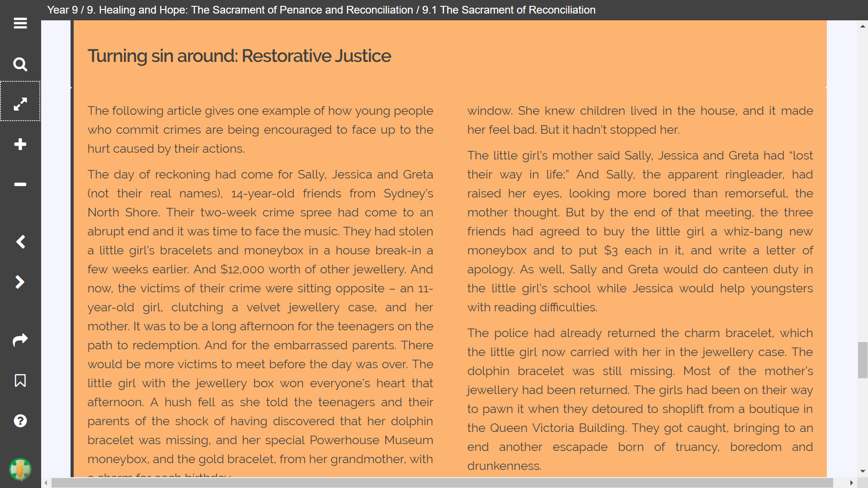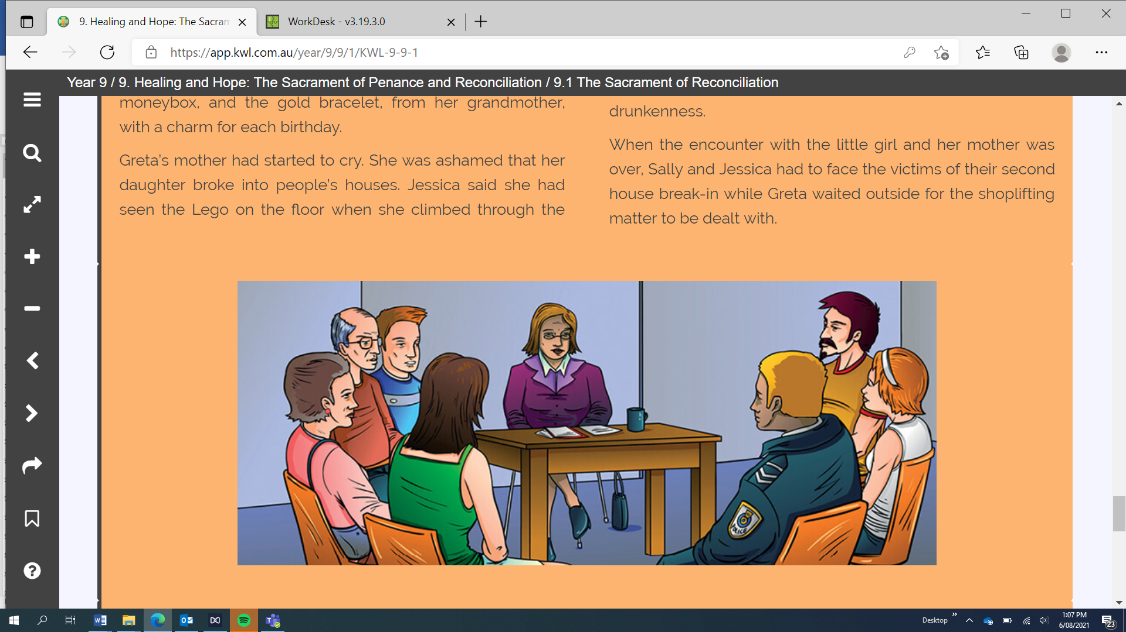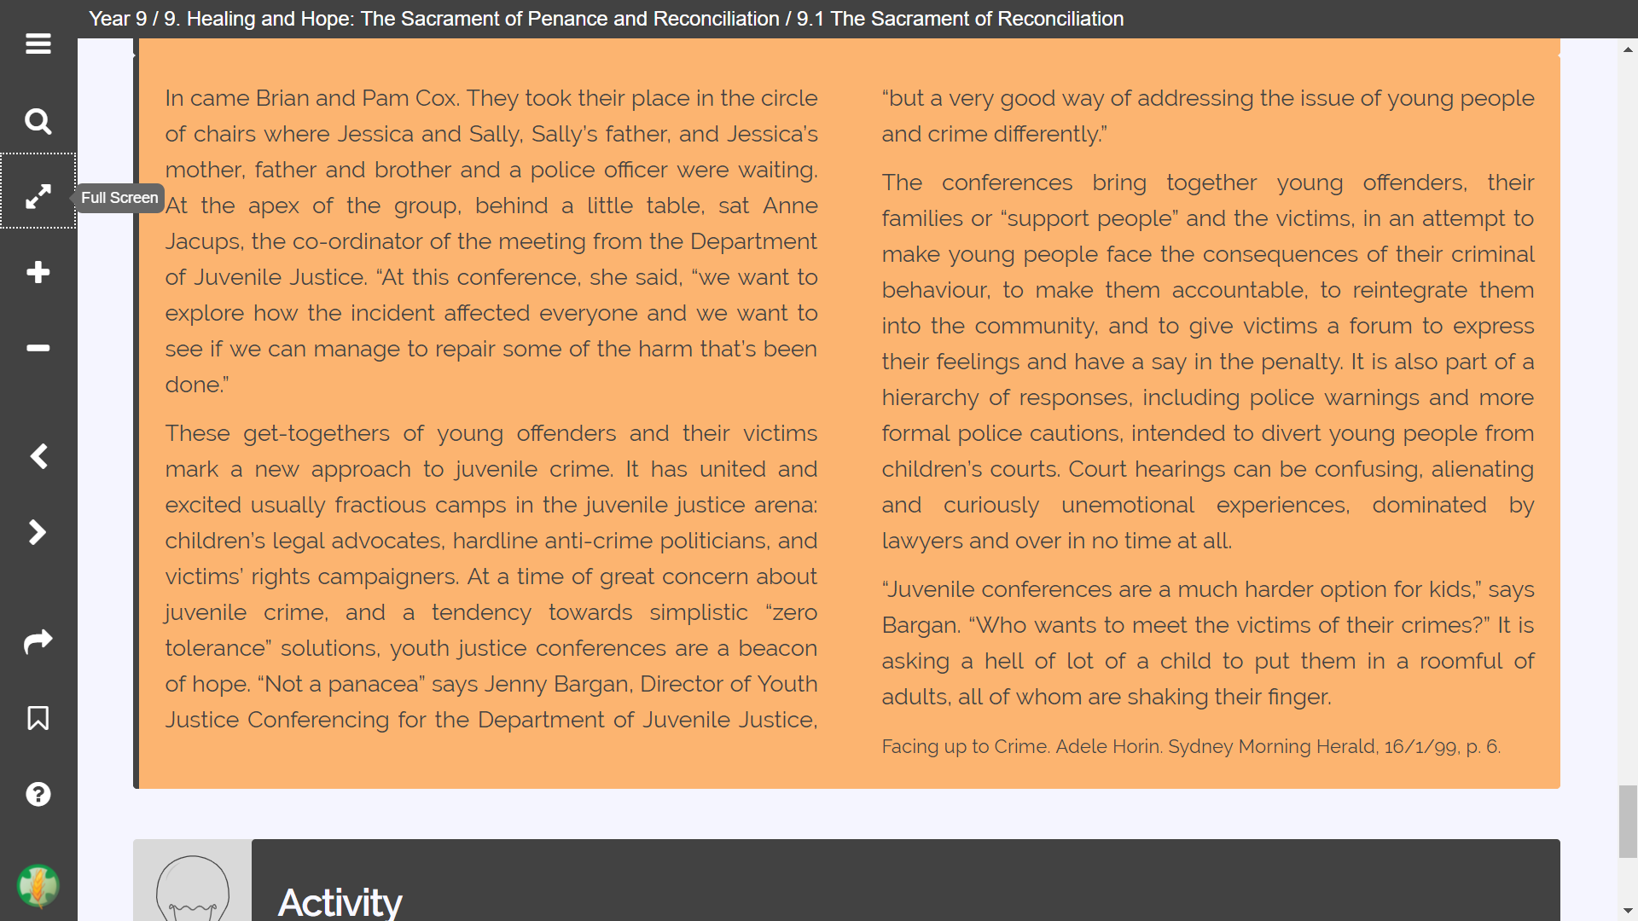

1. *Explain whether you think that Sally, Jessica and Greta thought about the effects of their actions on others while they committed the crimes.*

*No. They just wanted the goods and didn’t think of how it would affect the victims, which is why they willingly stole from a young girls.*

1. *Explain the concept of ‘restorative’ justice.*

*The wrong-doers restore themselves by doing good deeds and receiving forgiveness from the people they have done wrong to.*

1. *Within the parameters of this example, do you think that this approach would work? Why / why not?*

|  |  |
| --- | --- |
| ***Positive*** | ***Negatives*** |
| ***Items worth a lot*** | ***Get caught*** |
| ***Learn from your actions*** | ***Guilt*** |
| ***Buying a new box*** | ***Already did the damage*** |

1. *Identify some other scenarios where you think this may be a useful technique. HINT: Parade House Leaders use ‘Restorative Justice Meetings’ in certain scenarios. Why do you think this is?*

If the criminal is young and impressionable, restorative justice may be able to have a big impact on them, as they see who they have wronged and participate in activities to make up for it.

1. **Restorative Justice – why is it good for the Criminal and the Victim**
2. **Criminal (3 dot points)**

* Learn from the mistakes.
* Seek forgiveness.
* Suffer consequences so they don’t do it again.

1. **Victim (3 dot points)**

* Are apologised to by the criminals.
* Get their items back.
* Younger victims see what its like when you sin.

**The Sacrament of Penance**

**Read 9.2 The Sacrament of Penance from TKWL.**

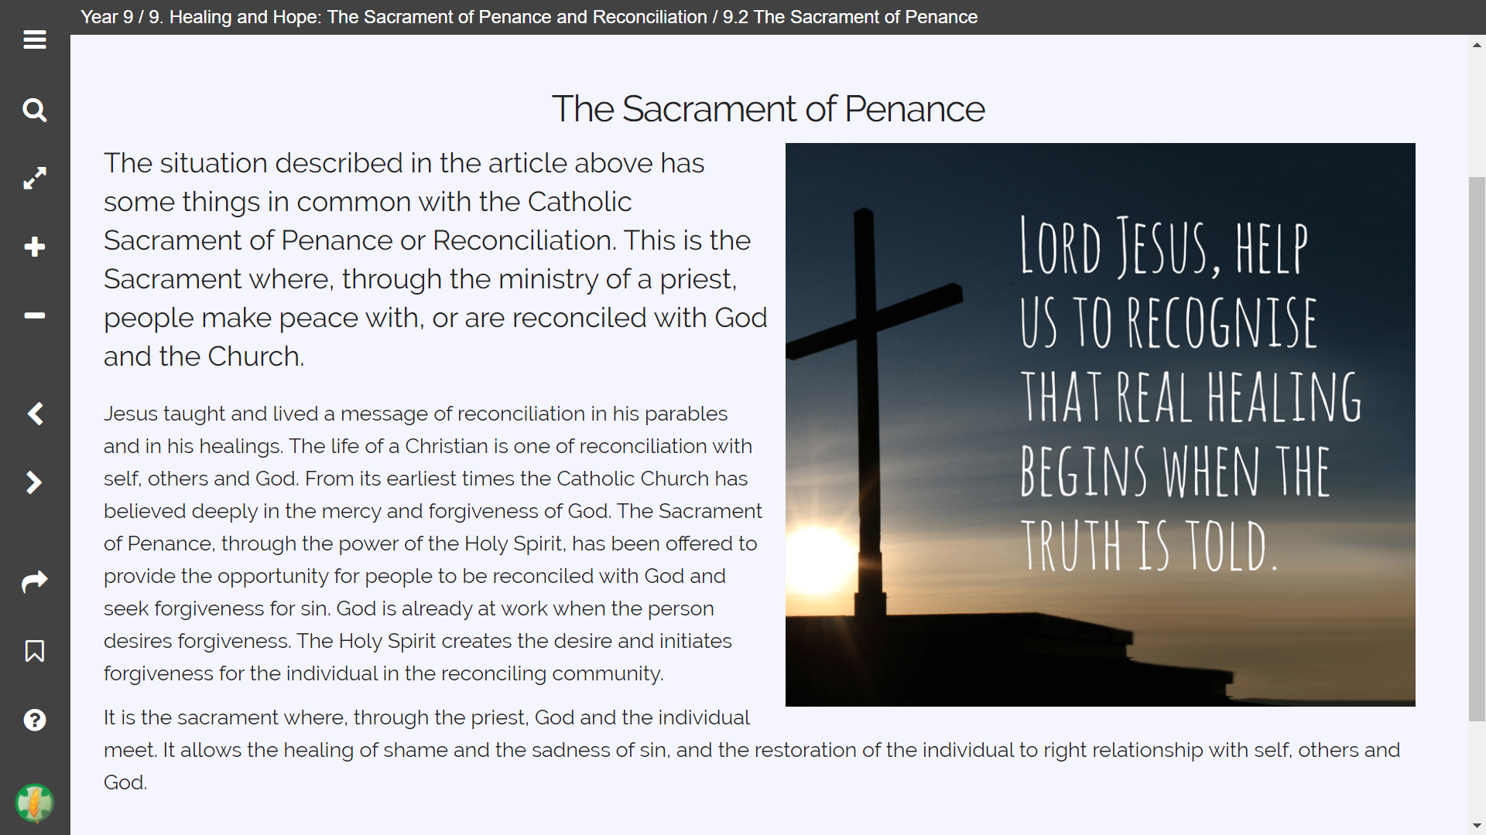

1. *What is the sacrament of Penance?*

*A ceremony that allows people to seek forgiveness and restore their relationship with God by meeting Him and confessing for what they have done wrong.*

1. *Summarise the history of Penance. How has it changed across the centuries? Think of at least ONE main dot point.*

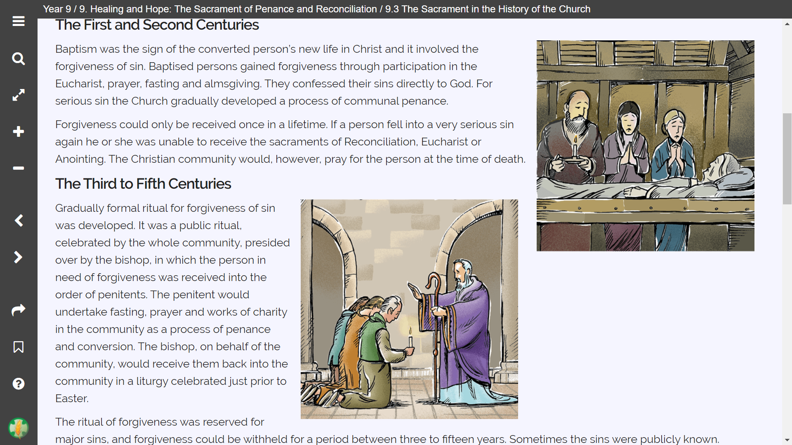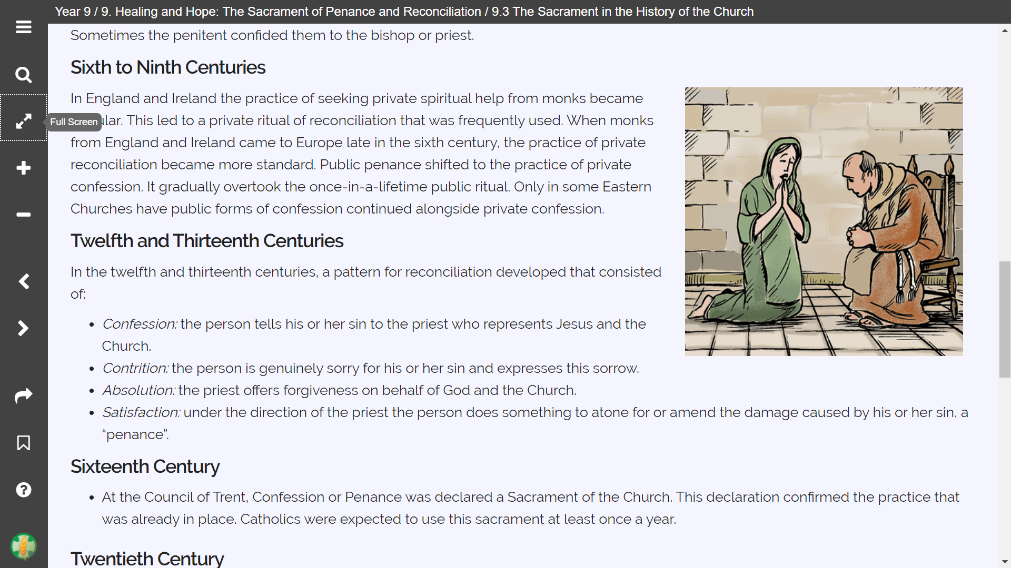

***1st – 2nd Century:*** *Forgiveness could only be received one time: Baptism.*

***3rd – 5th Century:*** *People seeking forgiveness would fast, pray, and do charity work.*

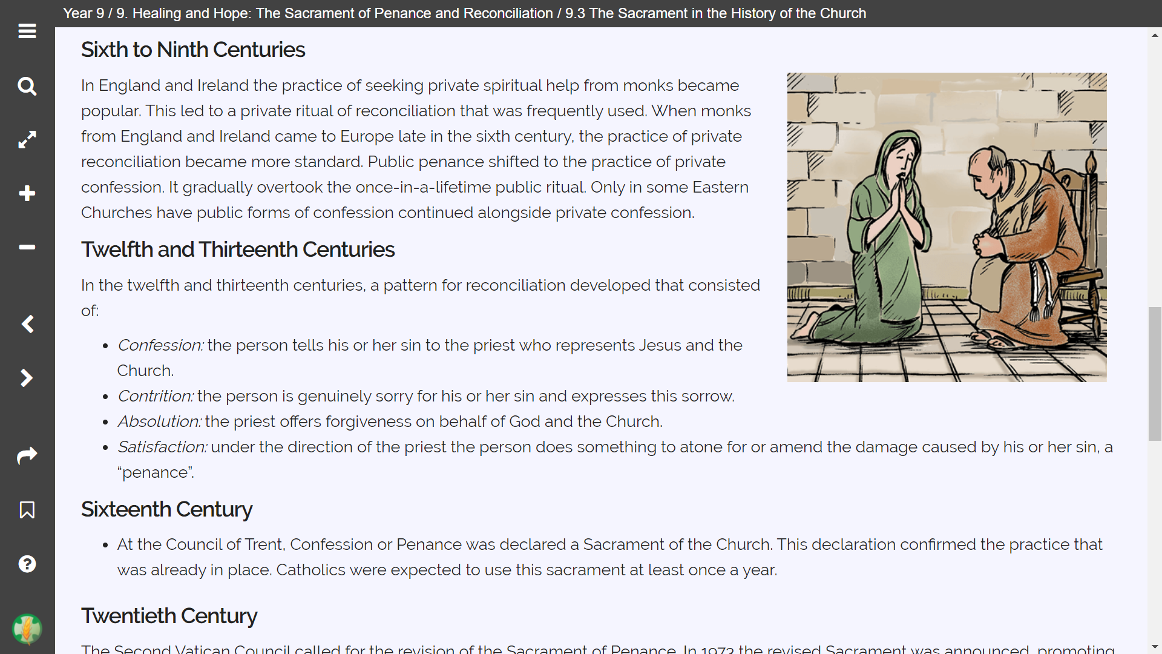

***6th – 9th Century:*** *Confession became private. You would also confess directly to a monk, rather than a bishop.*

***12th – 13th Century:*** *The pattern of Confession, Contribution, Absolution, and Satisfaction was popularized and normalized.*

***16th Century:*** *Confession officially became a Sacrament of the Church.*

***20th Century:*** *During the COVID 19 pandemic, one may have their sins forgiven if they felt truly sorry and truly wanted forgiveness, and the person wanted to show true interest in receiving the sacrament as soon as possible.*

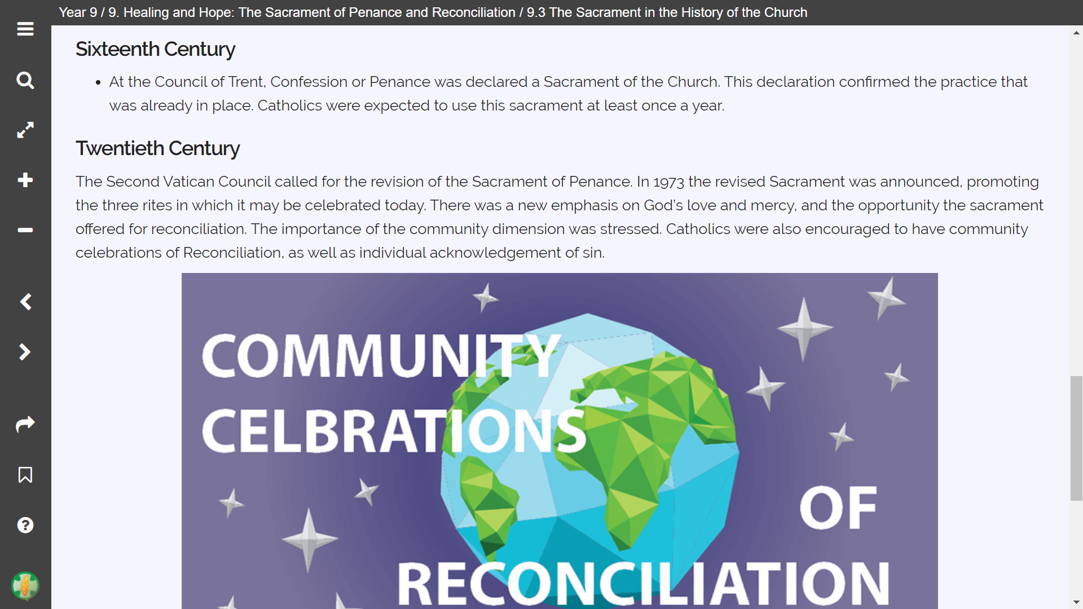

**The Three Rites of the Sacrament of Penance**

Read **9.4 The Sacrament of Penance Today** in TKWL. Complete the table below.

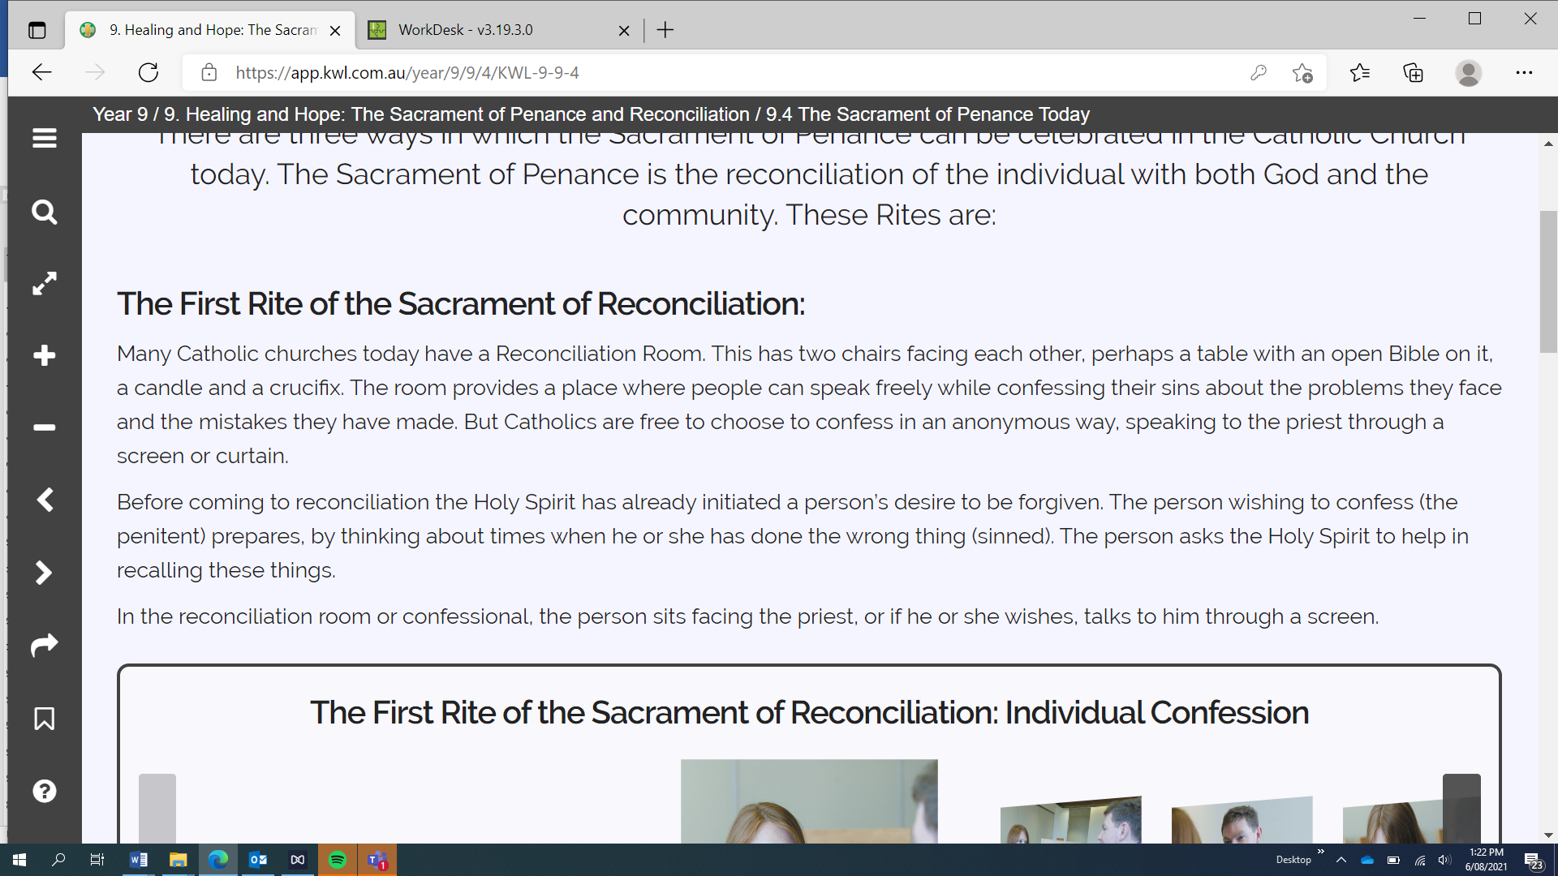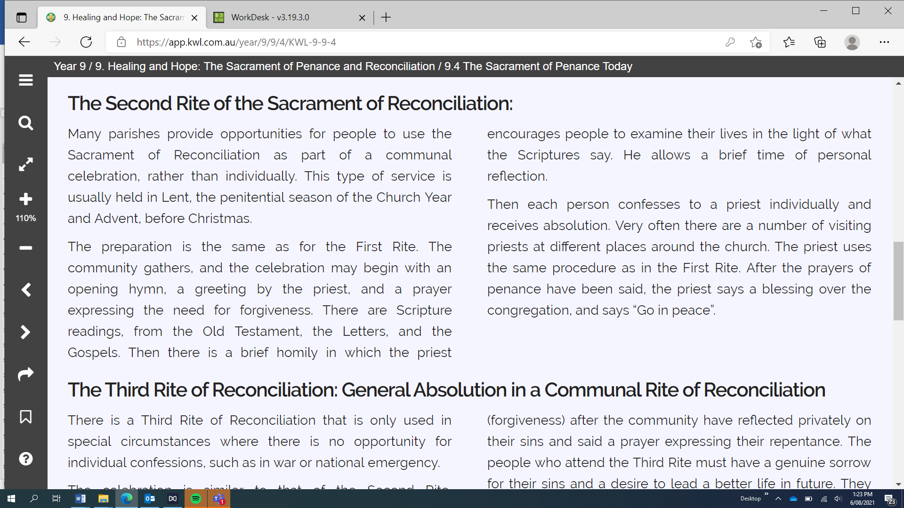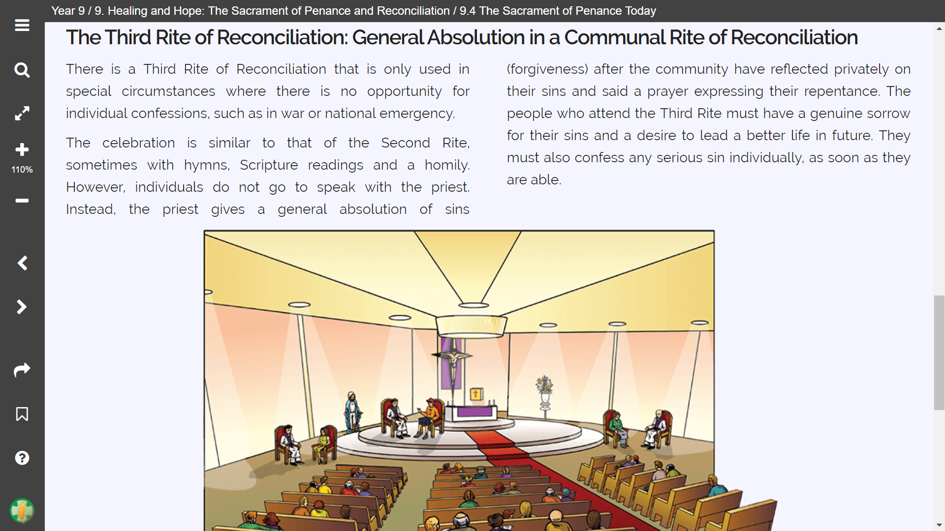

|  |  |
| --- | --- |
| **Rite** | **What happens in this rite (summarise in dot-points)** |
| First Rite: also known as…  **Individual Confession** | * Consists of two chairs, a table, and a bible, crucifix, and candle. * A priest is in the room, and you can ask for a screen between you and the priest, if there already isn’t one. * The person seeking forgiveness has already had the desire to seek forgiveness. * They ask the Holy Spirit to help them remember sins they have committed. |
| Second Rite: also known as…  **Communal Celebration** | * A communal celebration, one which is not individual and consists of more than the sinner and the priest. * It is usually held in Lent. * The ceremony may begin with a hymn, prayer, or greeting from the priest. * Each person gets the opportunity to speak to the priest individually. |
| Third Rite: also known as…  **General Absolution** | * This ceremony is only used when the First Rite can’t be used, such as during war. * It is similar to the Second Rite, but rather than the priest absolving everyone’s sins individually, the priest absolves everyone at the same time. * Everyone attending must have a true desire for absolution, and must confess any serious sins individually when available. |

**Watch the video How Do I go To Confession on You Tube** <https://www.youtube.com/watch?v=Ib8pzvnnL20&feature=youtu.be>

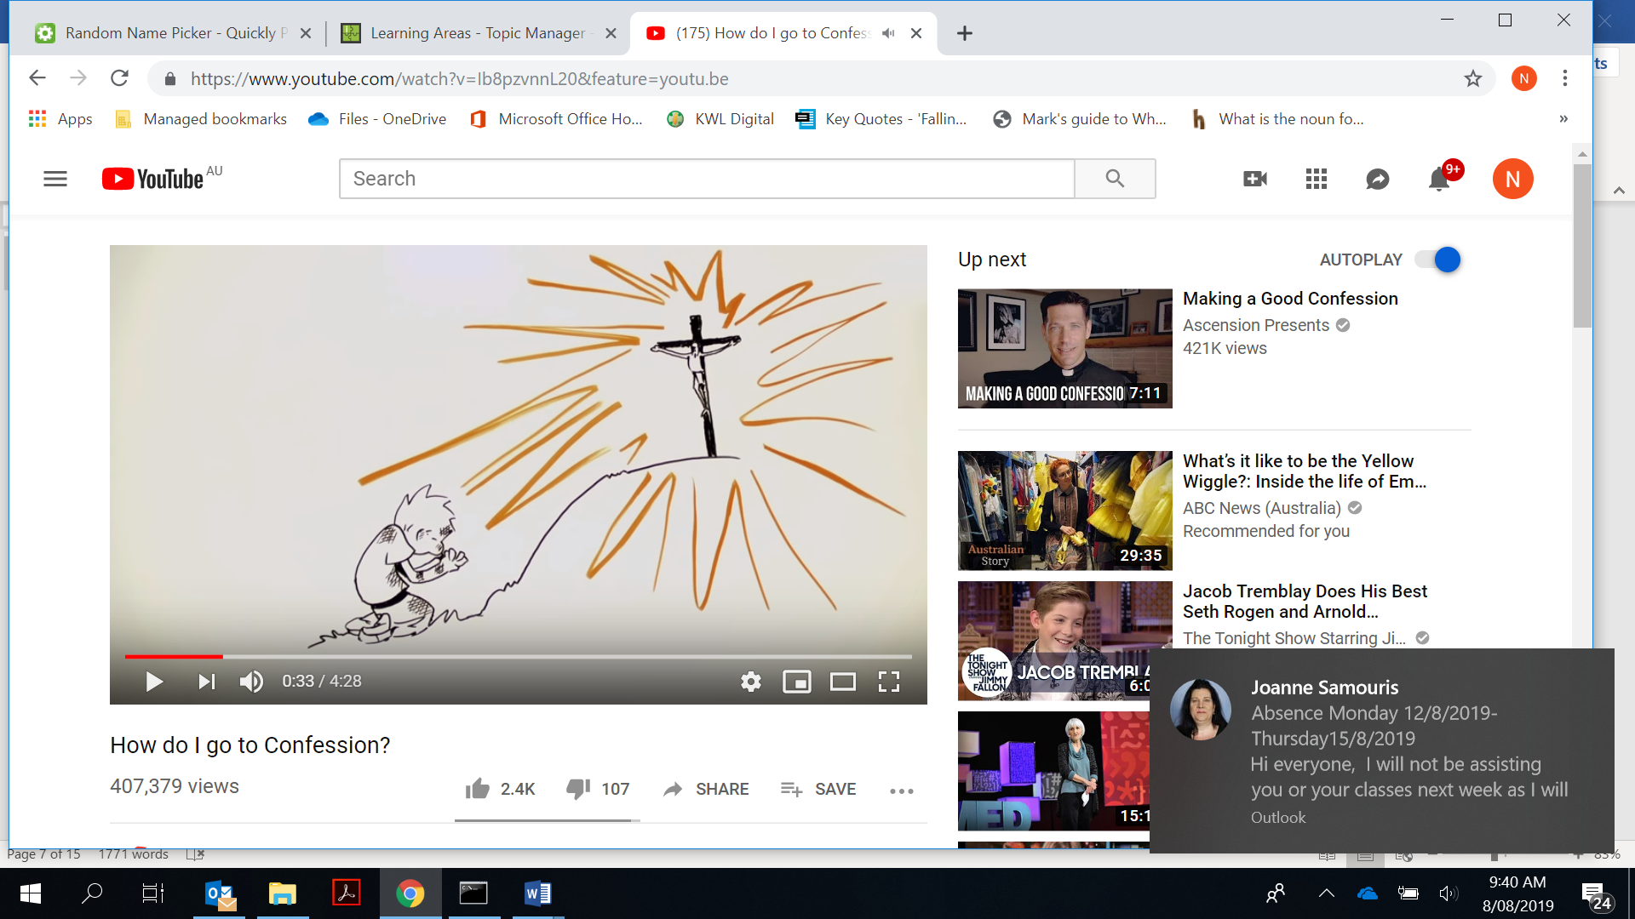

1. *Note down the steps of Confession*
2. *Contrition.*
3. *Tell how long since your last confession.*
4. *Confess your sins.*
5. *Penance – the Priest gives you things to do to make up for what you’ve done.*
6. *Act of Contrition*
7. *Absolution*
8. *Satisfaction*
9. *What is it called when you recognise what you have done and what you have failed to do?*

*Contrition.*

1. *Give an example of what the Priest might tell you to do to show that you are sorry?*

*Pray some prayers, help out your community, help your family.*

1. *What is the Act of Contrition?*

*Recognising your sins and wrongdoings.*

1. *What is Absolution?*

*The forgiveness for all your sins by God. If you are truly sorry, you will be forgiven.*

1. *The video mentions its not just about stating our sins, why is Confession so important?*

*We apologize for what we have done and we leave a better person, doing things to right our wrongs and living a satisfied life.*